The Royal School
Crown Aided and C of E Aided

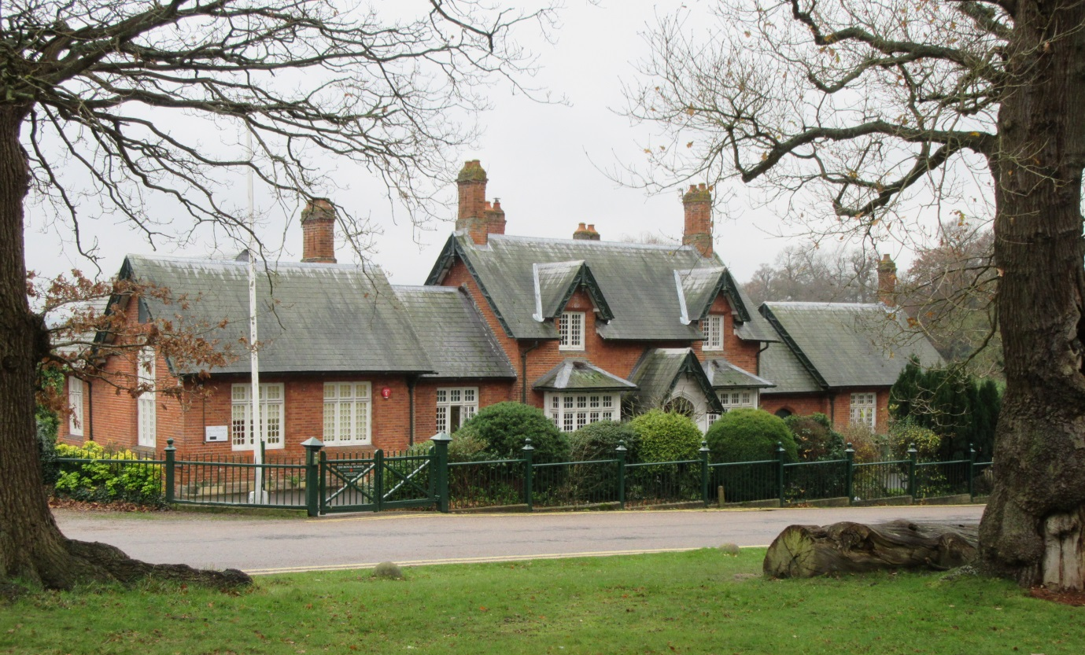
“Loving to learn, learning to love, guided by God”

Governors’ Report to Parents 2015-16

Governors Report to Parents
2015/16
Dear Parents,

We are almost at the end of a challenging, but rewarding year at The Royal School. Thank you for your patience and support through this time of change.

We have successfully recruited an experienced new Headteacher who is very much looking forward to working at our school. Beverley Coombridge brings with her a wealth of leadership skills, alongside a passion for music and utilising the outdoor environment. She will be working alongside Susan Calvert over the next two terms to ensure that there is a smooth transfer of leadership. May I take this opportunity to thank Mrs Calvert for the commitment, dedication and hard work given to our school. I’d also like to thank Miss Parsons for her tireless commitment to the school and the ‘backroom’ work that enables the school to move forward. Thank you also, to Mrs Kinghorn who has made an excellent job of teaching Years 3/4 this year. I’m sure many of her class have been inspired by her enthusiasm and skills in dance and drama. We wish you every success in your new life on the south coast. We are delighted that Miss Baldock has qualified as a teacher with flying colours and has been offered a position at our school.

Through careful management of the budget we have also managed to afford an extra fully qualified teacher for four mornings a week. This will allow us to get closer to our goal of five full time teachers. At present we have not managed to appoint a teacher due to the shortage of teaching staff in this area but we do hope to have filled that position by the end of the year. We do know that our teaching staff will consist of Miss Parsons, Mrs Tizzard, Miss Baldock, Mrs Teeder and Mrs Collison. Mrs Coombridge will be working with the older children on Fridays as she has a one-day teaching commitment in place.

Through our Ethos Group we have been looking at the vision and values of our school. It is important to set an aspirational vision and early in October the children formulated a learning motto’ ‘Inspired to Learn’ through a whole school workshop. As the year progressed the staff and governors carved out a vision and values statement and a new mission statement, ‘Loving to learn, Learning to love, guided by God’.

“To nurture and inspire all children through our Christian Values to become confident, caring and responsible individuals who can achieve personal excellence through a love of learning and a enriched, stimulating and effective learning environment.” (Mission and Vision Statement)

We embrace our FAMILY statement but have added six new Christian Values, which we feel underpin everything, which we feel we stand for as a school and each year group has adopted a value.

Foundation – Love, Year 1 – Honesty, Year 2 – Respect, Year 3 – Wisdom, Year 4 - Service

We feel that it is important that our school embraces our Christian distinctiveness. It is a school where we aspire towards high quality education and ambitious standards, and, of course, where as a community we can work together in harmony and with respect for all our stakeholders. We really value our staff and as such we have worked to improve the working conditions of our school environment. This is especially important for our office staff that work tirelessly to ensure the smooth running of the school. This year we have redesigned the staff recreational area with a new office and staffroom spaces fit for purpose. Three of the four classrooms have been redecorated and new furniture bought where necessary. We would all like to thank the Crown Estate for their continued generous support with the maintenance and aesthetics of the school and for governors who have fundraised for the school.

Overall, the Governors are responsible for the strategic direction of the school. We monitor the school improvement priorities through regular visits, scrutiny of documentation and Governing Body meetings. The governors are wholly committed to the success of our school and work tirelessly to move our school forward. The Head teacher works with the whole school community to identify priorities, plan and action developments for these, and to closely review outcomes. We have monitored the school very closely this year and are pleased to be able to report to you the many and varied opportunities your children have been able to experience this year, together with their successes.

We strongly believe now that our school is good and we wait eagerly to see that Ofsted will qualify this judgment. As a Governing Body we have had an external review and our processes and procedures are deemed efficient and effective.

Next year we plan to make no substantial changes to the classroom organisation, curriculum or timetable. We do plan, however, to change the classrooms around so that they are best suited to the children. Year 1 will be moving next to the Wrens’ classroom so they can access the outdoor space and Year 4 will be in the Robin’s old classroom. To minimize the transitional effect that any changes may have on the school community we aim to make the last week a transition week where children will spend the last four days in their new classroom with their new teacher.

I wish all our leavers every success on the next step of their education. Again thank you for your support and commitment. I know we have the very best PTA possible, where no task is too big and without their/your support many of the ‘extras’ we provide would not be possible.

Very best wishes
Yours truly

Viv Benn
Chair of Governors

What are we trying to improve?
There are many priorities in our School Improvement Plan which can be found below or for more information on our website
http://www.theroyalschool.org.uk/website/our_vision_statement_/210352

1. Excellent outcomes for pupils
- Audit the quality of assessment, revise the marking and feedback policy and practice and develop systems to ensure consistency and high quality.
- Challenge for the more able, SEN/less able, boys and pupils who attract additional funding (PP) in:
  - Independent writing, SPAG and reading comprehension against age related expectations
  - Mathematics – core mental maths and mastery skills (articulating and reasoning)
- In EYFS harness high quality learning behaviours for mastery skills.
2. Quality teaching, learning and accurate assessment
- Improve the quantity of teaching to be good or better; including lesson protocols and marking/ feedback, which ensure that assessment, moves learning on and pupils are actively involved in the process.
- Increase the level at which pupils with SEND and less able pupils are provided for within class and by teachers
3. Personal development (confidence and resilience)
  - Further encourage pupils to be increasingly resilient in their learning behaviours
4. Strong leadership and management
- Further develop subject leadership skills whole school including planning and strategic direction, to include:
  - Staff and governors knowledge of what standard is expected in each year group with a thorough understanding of how data analysis can aid this.
- Clear monitoring programme involving subject leadership and governors
5. Productive engagement with and support from parents and carers
- Engage parents in the learning process at school and understand more about how they can support their child through their learning.
6. Our distinctive Crown links and Christian beliefs
- Improve the quality of the school environment, how to optimize the professional look of the building, use the space to its full potential and safeguard all staff and children.
- Review the Christian distinctiveness of the school and review this through the Statutory inspection of Anglican and Methodist schools.
7. Curriculum development matched to pupil need and interest, incorporating our unique environment
- Develop cross curricular links to further include English and Maths in the delivery of wider curriculum
- Review of curriculum; look at the level of enrichment activities and the balance of teaching and learning.
- Ensure consistency of classroom environment, expectations, displays, timetable and what we expect to see in the books.
8. Preparing children for their next stage in life and learning
- Opportunities for children to take risks; manage their learning and relate the work they do in schools to their ambitions in their next stages in life.
Where have we seen improvements this year?

To ensure that all our children have exposure to a high standard of education we have tailored our core curriculum so that all learners are engaged at the right level of challenge and support. The success of all students is down to a strong foundation of the core subjects in reading, writing, and mathematics. The timetable from Monday to Thursday is structured and covers a phonics lessons (or if they are a little older SPAG - Spelling, Punctuation and Grammar), an English and a Mathematics lessons. Every day starts with Handwriting and group reading. We have chosen tried and tested educational programmes of study (Read Write Inc, Big Write and Abacus Maths) to ensure that we have high quality coverage and scope for the teachers to enrich and inspire the work load. All teachers have been well trained in delivering the new curriculum and all the new challenges.

We continue to provide high quality enrichment activities and a breadth of topic, creative and physical lessons to ensure all pupils excel. We have introduced a timetable in the afternoons to ensure that Years 2, 3 and 4 are working in specific year groups for many lessons. It is important that the pupils feel they belong together as a class. Leadership opportunities are available to all pupils but are especially exploited in Year 4. They continue to have a residential trio and visit Longridge.

Teachers have had the opportunity to visit outstanding schools and worked to moderate and assess standards throughout the year with many other partner schools. Learning walks, lesson observation and book scrutiny were carried out with LEA and Oxford Diocesan, school development partners. We have done a lot of work on our marking and feedback to pupils and we have been collecting progress data regularly. Success criteria have been decided and marking is delivered through ‘tickled pink’ and green for growth’ comments to enable children to understand what their next steps are to move the learning forward. Challenge is provided through differentiation of high quality teaching to attain ‘mastery’ and we have been running intervention sessions to support ‘catch-up’ programmes. The introduction of new lined workbooks has had a dramatic effect upon out handwriting and the presentation of the pupils’ work.

Obviously it is important to track the children’s progress so we have mapped every child’s progress so we are able to ensure that children are on target to reach their potential. Using provision mapping data we are on target for all year groups to exceed their year-on-year progress data using the benchmark of teacher assessment.

During the first few weeks we had an action plan in place to address key Ofsted criteria and created a school improvement plan to encompass all aspects of school development. Subject and middle leadership has been a focus all year. We have had many opportunities to work with other schools in this area and have been lucky enough to be awarded a specific amount of funding from the DFE. This money afforded the school the opportunity to work alongside consultants who could help the school analyse their progress and what the next steps would be to reach ‘good’ and beyond on Ofsted’s criteria.

We have written a new prospectus, welcome and induction pack and continue to refine our website so that it can provide up-to-date information for our parents. To help parents support their child we have an area on the website named ‘how can I help my child?’

http://www.theroyalschool.org.uk/website/how_can_i_help_my_child/210343http://

Our standards this year
OUTSTANDING

Our biggest achievement this year is to be judged by a SIAMS (Statutory Inspection of Anglican and Methodist Schools) Inspector as outstanding in all categories in July of this year. She is also an OFSTED inspector and her standards were very exacting. She judged:

“This provision richly exemplifies the school’s commitment to make clear everyone is loved by God and to value all its members. The same motivation is applied to guiding pupils’ academic attainment and progress. Under the guidance of the executive head teacher, improved assessment and tracking of progress has enabled insightful support and challenge to be given to groups of pupils so that all achieve as well as they can regardless of starting points. As a result, the drop in attainment and the poor progress the school experienced two years ago have been eliminated and the school’s results are good.”

“Marking is thorough and requires pupils to respond and improve their work. Teachers track progress carefully, always encouraging and supporting pupils to do better.”

“Since her appointment, the executive head teacher has worked tirelessly to improve standards and develop the Christian vision of the school. Success has been achieved through exemplary teamwork, with every member of staff living out Christian values to guide, support and inspire the pupils. Self-evaluation is rigorous and effective because staff and governors all have a good understanding of church school distinctiveness.”

We were absolutely delighted that she thought that we were outstanding especially as our standards in all the core subjects are integral to this result.

Our Early Years has ended the year with 87% of pupils achieving a ‘good level of development’. National Standards last year were 61% and we achieved 80% good level of achievement. In Year 1 the children have achieved a 90% pass rate on their Phonics test. Last year we achieved 76% and the national standards last year were 77%. This year the national standards are %. There is a marked improvement in the results in Year 1 and Foundation has improved remarkably due to the change in the organisation of the school.

As you are aware the new curriculum is more challenging. There are no national benchmarks at the moment but the curriculum is approximately 8 month harder. Our KS1 results identifying the children who have met national expectations are 80% Reading, 70% Writing and 80% Mathematics. In Reading 40%, Writing 30% and Mathematics 40% exceeded age related expectations.

The progress in Year 2, 3 and 4 from last year standards to this year standards have all increased by 3% to 38% across reading, writing and mathematics standards last year. There is no indication that our data have fallen due to the changes in the organisation of the school. There is also no indication of a gender gap. This is especially marked in Year 3 and 4 where these children have performed very well with between 55% and 65% Reading, Writing and Mathematics who are just above or exceeding above age related expectation.
What have we achieved this year?

Tractor Ride
Multi-skills training through Sports Coaching
Easter and Christmas Concert in The Royal Chapel
Summer Concert
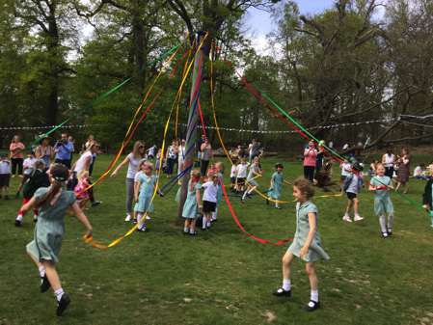
Royal has got Talent Show
Y4 Residential Trip to Sayers Croft
Whole School Pantomime
Trip to vineyard for Y4
Eton College Museum Trip
Christingle Service
Trip to Florence Nightingale’s Museum
Mothering Sunday Service in Royal Chapel
Whole School Sports Day
Leavers Ceremony and Old Scholars Day
Year 4 running the school
Her Majesty’s 90th birthday celebrations with parents
Shakespeare Workshop in Windsor Castle
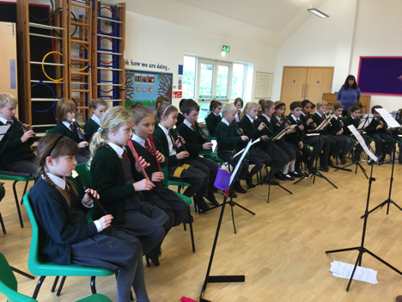
Visit from Father Lee
Roman Activity Day
Won Masterchef competition
Music Workshop and singing concert in St George’s Chapel
Literacy Day ‘Alice in Wonderland’
Outdoor Maths days led by LEA
Royal Forest Agricultural Show
Recorder recital led by Piers Adam
Choir session with Mr Manners
Harvest Festival and Nativity Concert
Trip to Longridge and fish and chip supper
Synagogue visit
Year 3 and 4 singing in the Royal Albert Hall
Whole school swimming
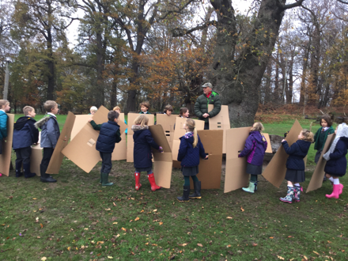
Y4 singing at Tyle Place
RE days for whole class including visitors
Blue Star and Christmas Parties
Whole school class assembly
Outdoor Maths day and Maths detective day
Sports Relief ‘Bake off’
Y4 Bikability sessions
Crown Estate Open day
Royal Ramble and cream tea
Summer and Christmas Fair
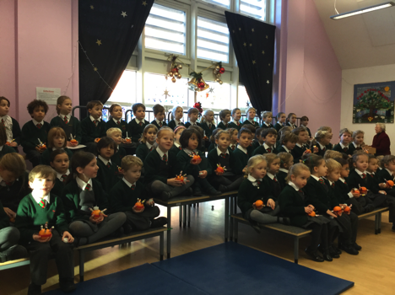
Windsor Sports Partnership PE training across school
Music opportunities in piano, flute, oboe and brass
Berkshire Maestros concert in Reading.
Celebration assemblies
Family assemblies
Head teacher awards
Lunch with the Head teacher

Designing a plaque for the bandstand at Alexandra Gardens , Windsor and singing an opening ceremony in front of HM The Queen

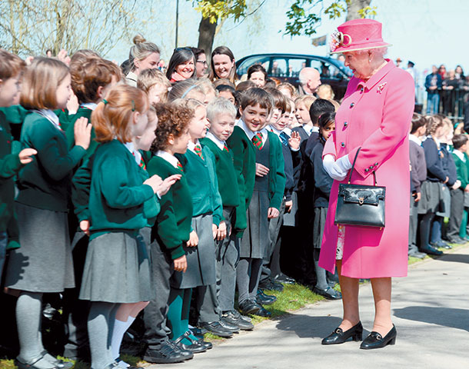

HRH The Princess Royal’s visit to the school in June as Patron of the BNF, the children and staff enjoyed the Healthy Eating week and were privileged to meet and talk with HRH as she spent time in each classroom and an assembly
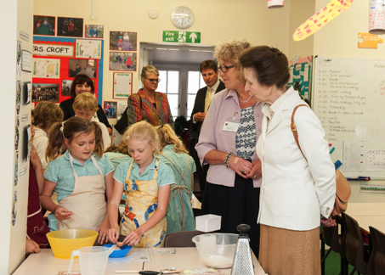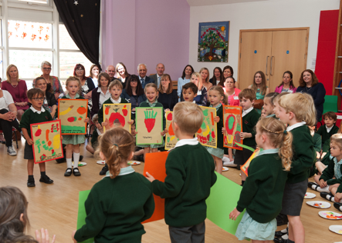

How are we working with parents?
We have a fantastic team of parents on the PTA who have raised many thousands of pounds for the school. This year they have achieved:
Children’s Disco
Christmas and Summer Fair
Spring fling
Refreshments at the Royal ‘Change Over’ during Ascot week
Summer Ball at the Wentworth Golf Course
Royal Ramble
Adopt-a-Pot (providing colour and beauty to our outside environment)

They have helped us to purchase resources to support the school including SEN materials, phonics books and a writing scheme, laptops for the children, lunchtime tables and much, much more.

Thank you for your continued support

The Royal School
Crown Aided and C of E Aided

Dear Parents

Please find enclosed an updated copy of our Governor’s Report to Parents with our latest progress data for the end of 2015-16.

Our Early Years has ended the year with 87% of pupils achieving a ‘good level of development’. National Standards last year were 61% and we achieved 80% good level of achievement. In Year 1 the children have achieved a 90% pass rate on their Phonics test. Last year we achieved 76% and the national standards last year were 77%. This year the national standards are %. There is a marked improvement in the results in Year 1 and Foundation has improved remarkably due to the change in the organisation of the school.

As you are aware the new curriculum is more challenging. There are no national benchmarks at the moment but the curriculum is approximately 8 month harder. Our KS1 results identifying the children who have met national expectations are 80% Reading, 70% Writing and 80% Mathematics. In Reading 40%, Writing 30% and Mathematics 40% exceeded age related expectations.

The progress in Year 2, 3 and 4 from last year standards to this year standards have all increased by 3% to 38% across reading, writing and mathematics standards last year. There is no indication that our data have fallen due to the changes in the organisation of the school. There is also no indication of a gender gap. This is especially marked in Year 3 and 4 where these children have performed very well with between 55% and 65% Reading, Writing and Mathematics who are just above or exceeding above age related expectation.

We are really pleased to report that we have received an OUTSTANDING verdict form our recent SIAMS inspection highlighting the fact that:

“This provision richly exemplifies the school’s commitment to make clear everyone is loved by God and to value all its members. The same motivation is applied to guiding pupils’ academic attainment and progress. Under the guidance of the executive head teacher, improved assessment and tracking of progress has enabled insightful support and challenge to be given to groups of pupils so that all achieve as well as they can regardless of starting points. As a result, the drop in attainment and the poor progress the school experienced two years ago have been eliminated and the school’s results are good.”

Next year the classes will be arranged in the same organisation as last year with Foundation, Year 1, Year 2/3 and Year 3/4. We have appointed a teacher to educated Year 3 children for four mornings a week and our Year groups will no be called Wrens, Robins, Owls, Cygnets and Swans.

On Monday we will start moving the classrooms around so that all the children know which classroom they will be in and which teacher will be teaching them next year. By Tuesday morning you child will be registered in their new classroom. Year 4 will be registered in the hall as they are running the school for the day.

Your child will be in

Name

Classroom

Teacher

Our Year 3 class will be registered in their pastoral groups but they will have their morning lessons with their new teacher……..This teacher………The class has been split by ability and age and

The staff and I realise that this has been a challenging year and with this amount of change has been difficult to maintain a clear line of communication as areas of the curriculum have been adapting throughout the ear. It has also been a really buy year where we have participated in a variety of wonderful extra curricular experience which have been very specific to this year.

