The Royal School
Crown Aided and Church Aided

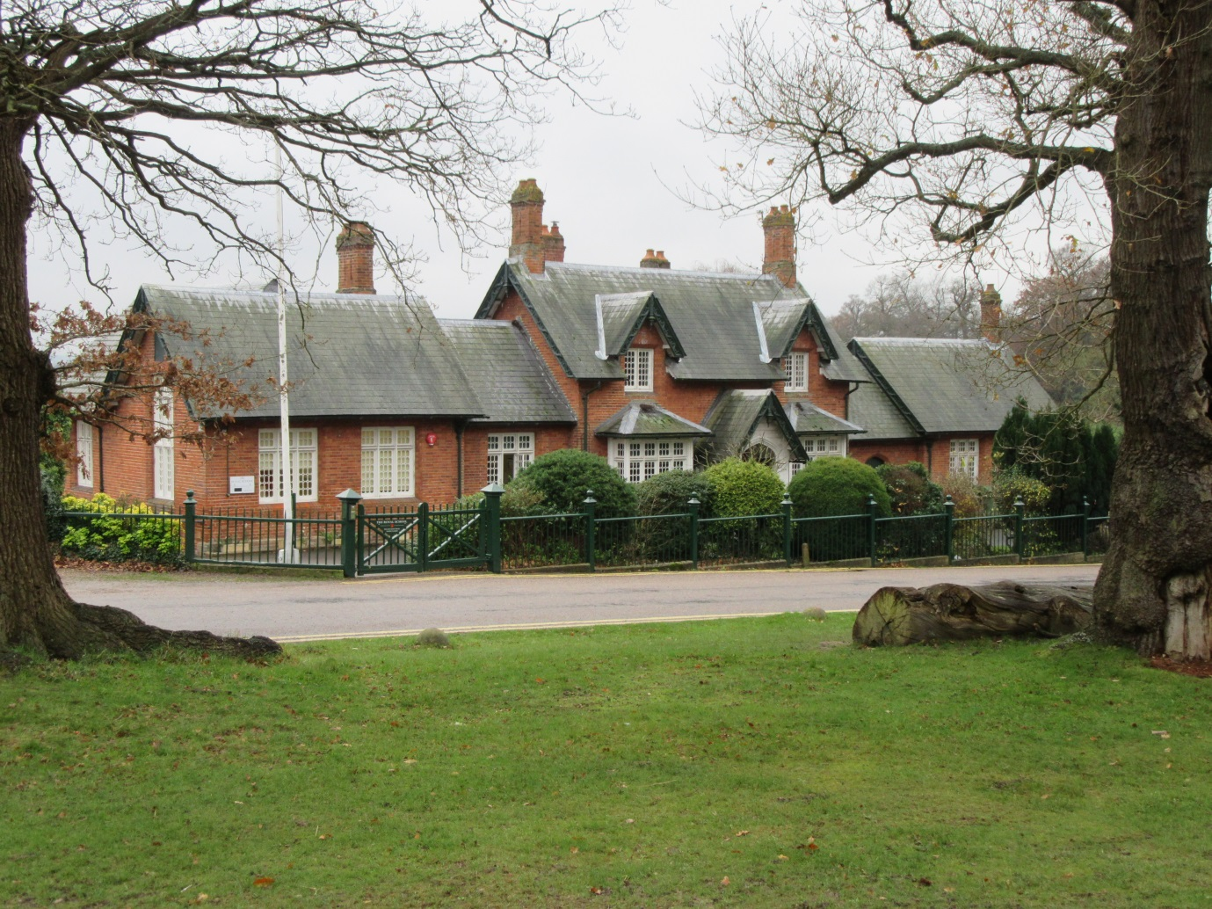

“Loving to Learn
Learning to Love
Guided by God”

The Royal School
(Crown Aided)
Church of England First School

The Great Park
Windsor
Berkshire
SL4 2HP

Telephone: 01784 434274

E-Mail: theroyalschool@rbwm.org.uk

Website: www.theroyalschool.org.uk

Executive Headteacher: Mrs. Susan Calvert

Local Education Authority

Royal Borough of Windsor and Maidenhead
Town Hall
St Ives Road
Maidenhead
Berkshire
SL6 1RF
Telephone: 01628 798888

Oxford Diocese

Contents

Welcome to The Royal School

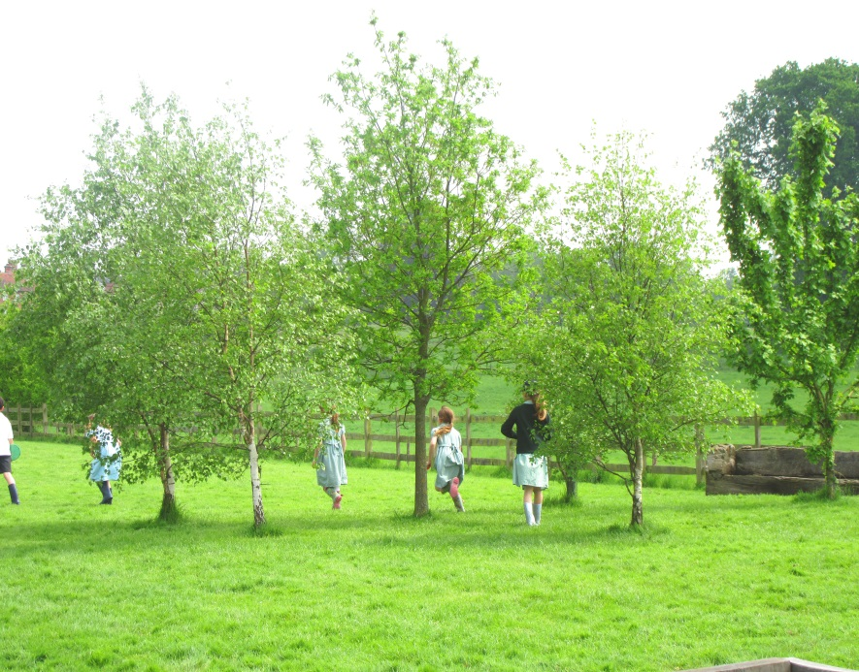

Welcome to The Royal School

Thank you for your interest in our very special school.

Children are normally admitted to our school in the September of the school year following their fourth birthday and leave at the end of Year Four. The education and welfare of children within our school strives to encourage all children to reach their full potential during their time with us.

Children need a breadth of experience so we aim to ensure that they are aware of and involved with the wider community. This is achieved in various ways, with visits to school by people from various walks of life and by participation in out of school events and educational visits.

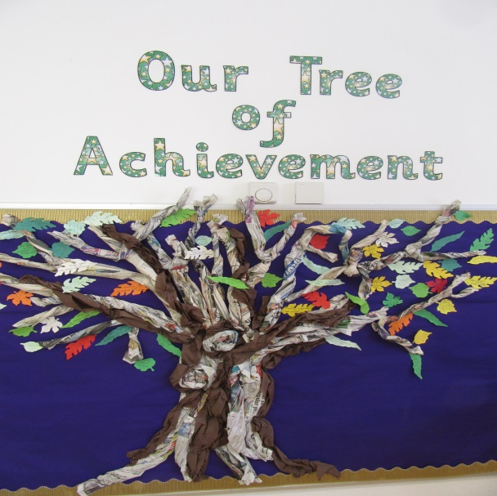
In accordance with our Christian ethos, we encourage children to think of others before themselves and to respect other people’s beliefs and religions even though these may be very different from their own. We encourage families to play an active part in the life of the school and to share in the education of their children.

Our history commenced in 1843 when Her Majesty Queen Victoria and Her Royal Consort, His Royal Highness, Prince Albert, decided that a school should be built to provide permanent provision for the education of the children of families in Her Majesty’s immediate service within The Great Park.

It was hoped that ”being thus brought under the influence of sound religious training and education in its true meaning, that they may not be forced to trudge through weary life without the aid of intellectual implements and tools”.

Since the opening of The Royal School in July 1845, successive monarchs have continued to demonstrate a close interest in its development and in the wellbeing of its pupils.

Uniquely, we are a Church of England Crown Aided (VA) school, within the Royal Borough of Windsor and Maidenhead (RBWM) and the Diocese of Oxford. We aim to provide a safe, secure and caring environment, and nurture a Christian ethos of mutual respect where differences are celebrated and the beliefs of others are valued. Our Christian ethos and royal connection gives a special dimension to our character and values.

We are very much part of the local Crown Estate community and have a strong association with the Royal Chapel (The Queen’s private chapel in the Great Park, which effectively serves as the local parish church). Long-standing traditions include children from the school taking part in the Mothering Sunday Service at the Royal Chapel in the presence of Her Majesty The Queen, participating in the Royal Forest Agricultural Show in the autumn and each summer greeting the royal party as it goes by horse and carriage from Windsor Castle to Royal Ascot.

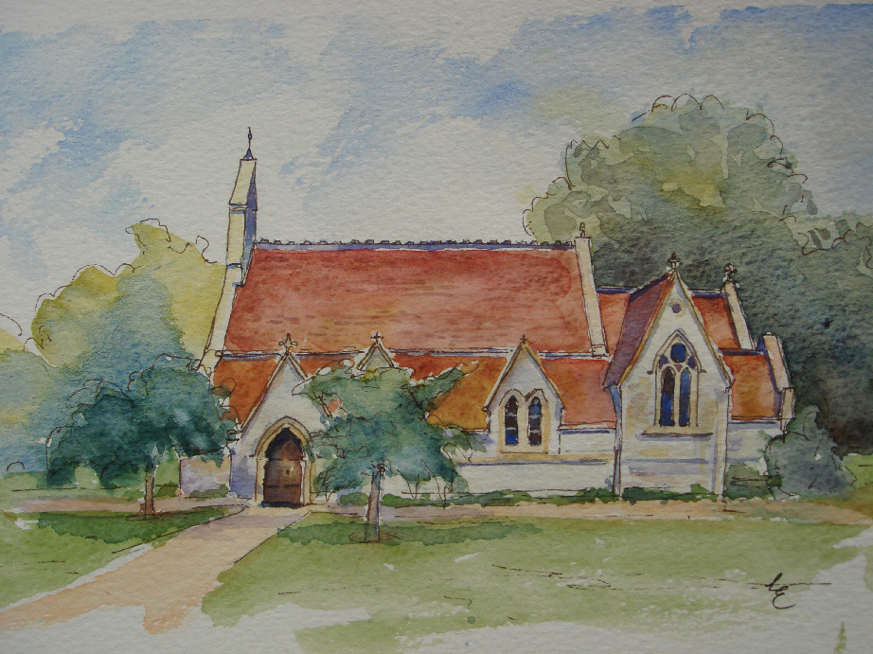

Ethos and Mission Statement

Recognising its historic foundation, The Royal School will preserve and develop its religious character in accordance with the principles of the Church of England and in partnership with the Church at large.

Our school curriculum is underpinned by the values that we hold dear at our school. The curriculum is the means by which the school achieves its objective of educating children in the knowledge, skills and understanding that they need in order to lead fulfilling lives.
Our school values statement is:
Faith in our Christian Values
Achieving our full potential
Motivated to succeed
Inclusive and caring
Learning at our heart
Supported by and supporting our CommunitY

This is displayed around the school through ‘Our Crown of Success’ which takes the 6 key words of Faith, Achieving, Motivated, Inclusive, Learning and Community.

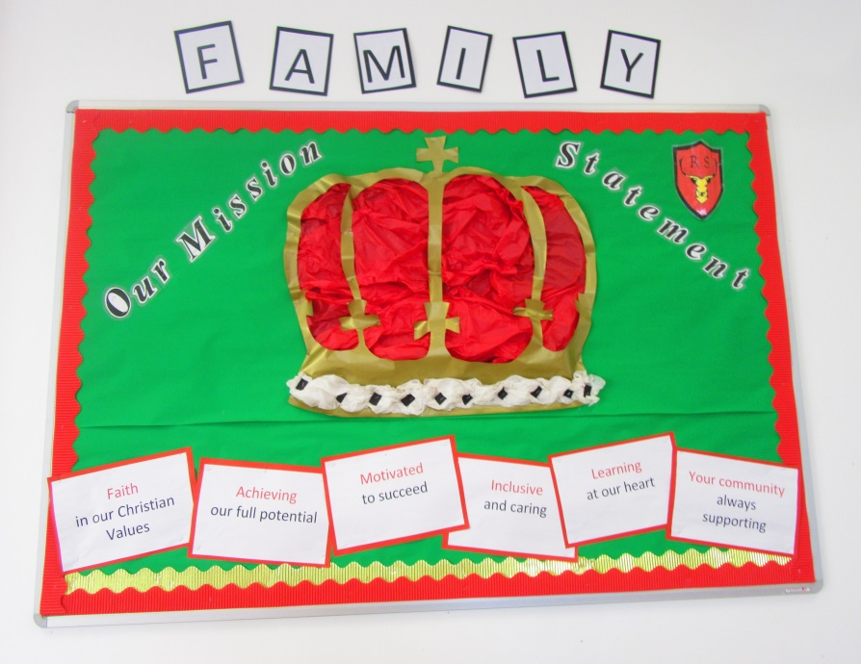

Each class has a Christian Value

Love
Honesty
Respect
Wisdom
Service
Family

The Royal School Philosophy

In our society, the educational system is one of the primary agents of socialisation for the growing child. We believe that this first school experience should be a natural stepping stone from the ideal represented by a happy and secure family environment. We seek to provide sound moral education based upon a Christian foundation within which all children may advance towards the achievement of their fullest potential.

Within this framework we encourage individual growth according to both ability and need. We teach our children to be positive and constructive in word, thought and deed so that, as young adults, they may leave the school system equipped to continue to mature into well-balanced members of our society.

We offer a sound progression within both the Foundation Stage and the National Curriculum and we work towards the concept of increased opportunity for personal choice and self- motivation as our children progress through this school.

We believe that children should learn how to use their leisure time wisely and that part of their education should include preparation for this aspect of their lives. An enquiring mind, carefully nurtured, should serve the developing adult well in later life.

STRUCTURE

The Royal School is a Crown Aided First School with a Christian ethos, adopted by the Diocese of Oxford, as well as having close links with The Royal Chapel.

Children normally enter the Foundation Stage in the September of the academic year in which they celebrate their fifth birthday and in general, leave for local Middle Schools at the end of the school year [Year4] in which they become nine.

The building consists of a Hall, four main teaching areas, library, kitchen, storage and administration areas. A suite of small rooms for group activities is situated in the walled garden area. Hard play and grassed areas are used for play / sport activities.

We have recently installed a new outdoor play area which was purpose built for the Foundation Stage children.

There are at present four classes –

Wrens - Foundation Stage
Robins - Year 1
Cygnets - Year 2 and 3
Swans - Year 3 and 4

Year 2, 3 & 4 are taught in separate years groups in a class of 20 in the mornings and split in the afternoon as one class. Foundation stage children follow the Foundation Stage curriculum

The School Day

8.45 – Bell Rings
8.50 – Registration
8.55 – Guided Reading and handwriting
9.10 - Maths Lesson
10.15 - Break
10.30 Phonics and SPAG
10.25 - English Lessons
12.10- Key Stage 1 lunch
12.20 - Key Stage 2 lunch
1.20 - Lessons
3.10 - End of School Day

The National Curriculum
LITERACY/ENGLISH – Great emphasis is placed on the individual development of proficiency in reading, writing, phonics, listening, speaking and comprehension. The Government’s Literacy New Curriculum is implemented throughout the school to provide a dedicated literacy teaching time for all children. There is an emphasis on phonics, grammar, spellings and punctuation in accordance with new guidance.

MATHEMATICS/NUMERACY – Opportunities are given for the consolidation and development of essential skills and routines, problem solving, including the application of mathematical techniques to everyday situations, and also to appropriate practical and investigative work. The government’s New Curriculum is implemented throughout the school with a focus on basic skills and mastery challenges.

SCIENCE – The main emphasis is placed upon the growth of scientific skills such as observation, experimentation, classification and measurement. The school fosters the development of scientific attitudes such as curiosity, critical thought, open-mindedness and co-operation, as well as seeking to encourage the children to form the hypotheses at each stage of their work.

RELIGIOUS EDUCATION AND COLLECTIVE WORSHIP – The spiritual development of each child is taken with the utmost seriousness and seen in the widest possible context. The Royal School aims to help all children to grow and mature and to take responsibility for their own decisions, including those concerning religious beliefs. During the weekly religious education lessons, themes and guidelines taken from the RBWM R.E. Agreed Syllabus and other sources are used. The daily acts of collective worship are led by the staff and children, outside organisations and the Royal Chaplain from The Great Park, Reverend Canon Martin Poll. The collective acts of worship [assemblies] have a specifically Christian theme, but care is taken to include aspects of other faiths. Each class has the opportunity to lead their own class assemblies each term. Termly assemblies, an annual Carol service and School Leavers’ Service are held in The Royal Chapel. Children also participate in Sunday morning worship when requested by The Royal Chaplain.

Parents have the right to withdraw their child from R.E. / Collective Worship and are invited to discuss this further with the Chairman of Governors and the Headteacher.

INFORMATION COMMUNICATION TECHNOLOGY – The school aims to ensure that all children can effectively use computer systems before they leave. Each child is given experience of saving and retrieving work and using modelling, control and handling programmes. Other aspects of Information technology are also covered within the curriculum.

PERSONAL, SOCIAL AND HEALTH EDUCATION – Appropriate aspects of the care of the human body and general health issues are covered as part of the PSHE programme.

HISTORY AND GEOGRAPHY – The school seeks to broaden each child’s experience and understanding of life beginning with the immediate and familiar home and local situation. The courses then gradually branch out to study other communities at home and abroad within an historical and geographical context.

ART– The school encourages the expression and appreciation of the arts in its various forms, plus individual creative expression using a variety of media.

MUSIC – Musical appreciation, performing skills, simple composition and singing are encouraged throughout the school. Piano, trumpet, ‘cello and violin lessons are currently offered by arrangement with individual teachers and the Berkshire Young Musicians Trust. Children are also encouraged to attend courses organised by the Trust.

PHYSICAL EDUCATION – The School’s aim is to develop fitness and growth of skills through participation in sports and activities such as football, netball, rounders, cricket, swimming, gymnastics, dance and keep fit. It is an expressed aim to ensure that each child is able to swim before leaving The Royal School. We belong to the School Sports Partnership in Windsor and often benefit from access to specialist PE provision alongside Sports coaching to support our PPA.

DESIGN AND TECHNOLOGY – All children are encouraged to identify a need or a problem and then to find practical ways of achieving a solution. As they progress through the school, children are required to develop their design, construction and evaluation skills.

LEARNING SUPPORT/ SPECIAL EDUCATIONAL NEEDS

In accordance with the National Code of Practice, it is our policy to provide early identification of special needs and to ensure that all children remain with their peers as much as possible. Consultation with parents takes place at formal and informal reviews. To ensure that all children have the opportunity to access the curriculum, an Educational Psychologist for the Royal Borough of Windsor & Maidenhead, and other appropriate outside agencies are available for consultation when there are concerns about a particular child, or special needs / disabilities have been identified.

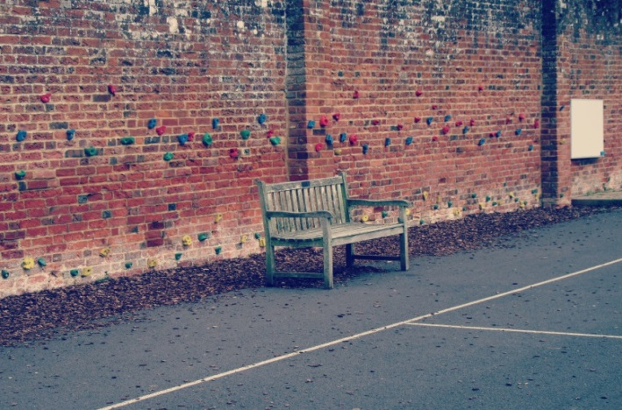
The Governors have undertaken to ensure that the necessary provision is made for each child with Special Educational Needs and will report to the parents at their Annual General Meeting on the effectiveness of the school’s Educational Needs Policy.

Gifted and able children access the curriculum, as appropriate to their needs.

THE GOVERNING BODY’S POLICY ON SEX EDUCATION
Appropriate aspects of the care of the human body and general health issues are covered as part of the PSHE programmes. The school has a specific policy regarding sex education. It is our policy that due to the age of our pupils it is inappropriate for us to teach sex education. If discussion occurs informally within a natural context as and when children raise particular points then teachers respond as would caring and concerned parents.

HEALTH AND SAFETY
In order that contact can be made as soon as possible if a child becomes ill in school, parents/guardians are asked to complete an emergency contact form. These are regularly updated and held in the school office.

First aid is administered in school for minor accidents. If hospital treatment is required, every effort will be made to contact a parent / guardian in order that they may accompany the child to hospital. Failing this, the school will make arrangements for the child to be taken to hospital and will continue to make contact the parent as soon as possible. An adult from school will accompany the child.

Fire instructions are displayed around the school and there is a regular termly fire practice.

Any areas of concern regarding general school health and safety issues are reported to the Headteacher, who will ensure appropriate action is taken.

ADMINISTRATION OF MEDICATION IN SCHOOL

According to guidelines issued from the Local Education Authority, the Headteacher and staff are not legally obliged to administer medication to children in school. They may however do so providing the following procedures are observed.

Full details of the medication prescribed by a doctor are given, together with a written request for the administration.

The medication must be CLEARLY labelled with contents, dosage and the child’s name in full. (It would help if a measured dose were provided.)

Forms requesting the administration of medication are available from the School Office.

JEWELLERY

For safety reasons, children are not permitted to wear jewellery at school.

SCHOOL MEALS

School lunches are cooked on the premises and a main meal is provided every day by Caterlink who are sub-contracted by the Local Authority. Menus are sent home in advance so that parents may choose on a day to day basis from the options available. All meals must be paid for in advance or on the day.

If parents/carers consider their children are eligible for free meals, or have any queries regarding this facility, please speak with the Headteacher.

Facilities are provided for children to bring a packed lunch. This should be contained within a named secure bag or box and a plastic plate provided.

Children are not allowed to leave the premises during the lunch break except by permission of the Headteacher or if going home for lunch. Those going home should return between 1.15 – 1.20pm, ready for afternoon school.

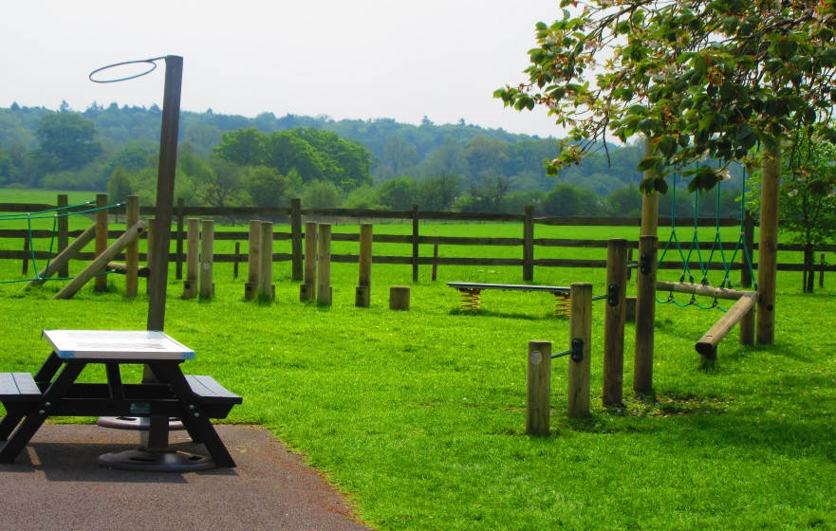

SCHOOL ATTENDANCE

It is a requirement by law that children are regularly educated. Parents are asked to send a note explaining the reasons for any absences when the child returns to school. A telephone call on the first day of absence must be made to the school office. If children come to school on their own, even a one day absence should be telephoned in prior to the commencement of the school day to ensure that all concerned are aware of the child’s whereabouts at all times.

Forms applying for term time absence are available from the School Office. It is not school policy to authorise any absence except in very exceptional circumstances. Parents must appreciate that any absence may result in missed opportunities within the school curriculum, so it is in the best interests of the child to avoid absences during school hours.

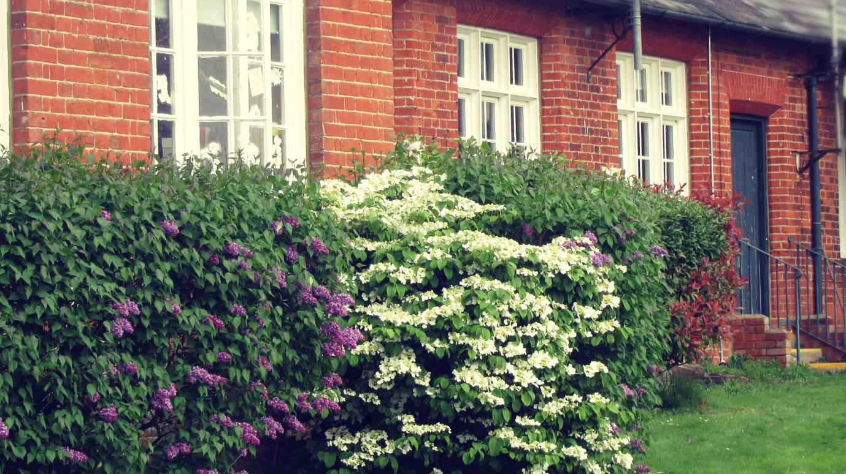

DISCIPLINE

Children are expected and encouraged to behave in a reasonable manner. Good manners and politeness are emphasised, with high standards of work and code of conduct encouraged. The aim is to use a system of positive reinforcement.

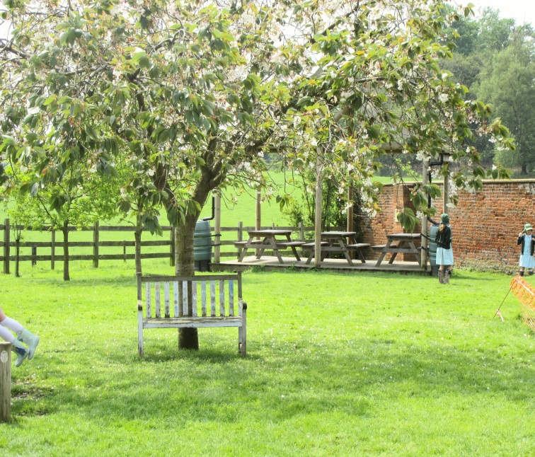
Children are awarded House Points for individual examples of good behaviour. We also operate a class reward system of ‘Blue Star Time’ which is reward time earnt collectively. A weekly merit assembly is held when each class identifies a ‘Star of the Week’ and that child receives a certificate and pencil. They also get a leaf to add to our ‘Tree of Achievement’ which is displayed in The Vinery Hall.

A copy of our Behaviour Policy is available for viewing at the School Office.

SCHOOL UNIFORM

Children must wear a basic school uniform as this creates a sense of pride in belonging, which is a vital within this small school situation. It also makes for ease of recognition when on school visits and avoids comparisons between children. A school dress code is included with this document.

HOMEWORK

The weekly recommended time allocation for home activities is as follows:

Years 1 and 2 (Key Stage 1) – approximately 1 hour per week to include:
- Reading[sharing books with adults]
- spelling
- number bonds
- other literacy and numeracy work.

Years 3 and 4 (Key Stage 2) – approximately 1.5 hours per week to include:
- reading
- spelling
- number bonds
- tables
- other literacy and numeracy work
- occasionally, a wider range of subjects.

The class teachers will explain tasks to the children and requirements might be written in a home/school diary if the task is not evident. Parents are requested to speak with the class teacher if they require further clarification. Support offered by families at home is very much appreciated.

If you would like to visit our school you would be warmly welcomed.

